Adham Suliman

Statistical Analysis

Homework 1

1.1)

What does this say about fairness of the coin? If it converges to .5, then the coin can be considered fair which it does as we see on the plot below.

nFlips <-100000

set.seed(12345)

Flips<-sample(0:1,nFlips,repl=T)

Trajectory<-cumsum(Flips)

freq<-Trajectory/(1:nFlips)

The plot below shows a longer sample length and shows that the frequency visually averages at 50% earlier than the second graph.

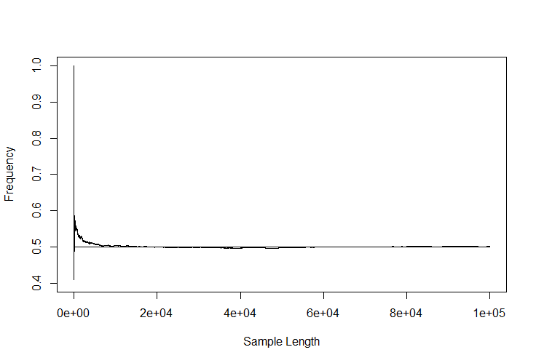

plot(1:length(freq),freq, ylim=c(.4,1),type="l",ylab="Frequency",xlab="Sample Length")

lines(c(0,nFlips),c(.5,.5))

The second graph looks at the beginning of the sample length show in the initial graph and it shows how the average frequency initially deviates far away from an average of 50%, but as the sample length moves into the thousands, it is clear that the average frequency approaches 50%.

plot(1:4000,freq[1:4000], ylim=c(.4,1),type="l",ylab="Frequency",xlab="Sample Length")

lines(c(0,4000),c(.5,.5))

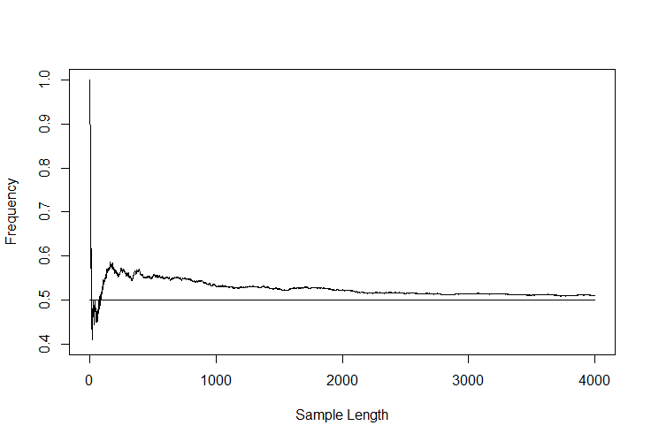

2.1 )

Find at least one alternative way of simulating variable Flips.

nFlips=10000000

Flips_alt<-rbinom(nFlips,1,.5)

trajectory_alt<-cumsum(Flips_alt)

How much do you expect the trajectory of wealth to deviate from zero?

It will deviate initially highly, but it will eventually average out to 0.

How long do you expect it to stay on one side above or below zero?

I believe it will begin to average out to 0 at around the 2000 mark as we saw in the second graph for the previous problem.

nFlips<-1000000

Flips<-(sample(0:1,nFlips,repl=T)-.5)*2

oneTrajectory<-cumsum(Flips)

plot(oneTrajectory, ylim=c(-1000,1000),type="l")

lines(c(0,nFlips),c(0,0))

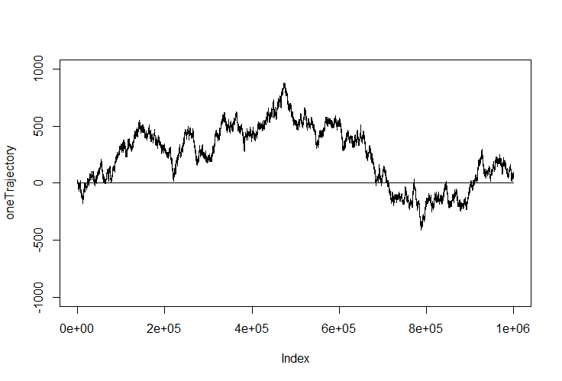

How do the observations match your prior expectations?

I was not expecting the summation to stay away from 0 a majority of the analysis. The data seems to stay substantially far away from 0 until around an index of 6e+05.

2.2)

What do you expect the probabilities of the following events to be?

I expect the probability of the first to be between 15% and 20% and the probability of the second to be lower than 5%.

For P(Nh-Nt)<5:

pbinom(255,500,prob=.5)-pbinom(245,500,prob=.5)= 34.5%

For P(Nh-Nt)>25:

pbinom(274,500,prob=.5,lower.tail=FALSE)*2= 2.83%

Turn the sample Flips of 1,000,000 coin flips into 2000 random walk samples, each is 500 long. Calculate 2000 cumulative trajectories???

For the trajectories less than 5 points away from 0, I was expecting a probability between 10% to 20%.

For the trajectories more than 25 points away from 0, I was expecting a probability between 20% and 30%. I would expect the probability of the first to be lower since there is such a large number of samples that I t would be improbable to find a mean within 1% of the true mean.

set.seed(12345)

Trajectories2000by500<-t(apply(matrix(Flips,nrow=2000, ncol=500),1,cumsum))

dim(Trajectories2000by500)

(probability.less.than.5<-sum(abs(Trajectories2000by500[,500])<5)/2000)=18%

(probability.greater.than.25<-sum(abs(Trajectories2000by500[,500])>=25)/2000)=25%

2.3)

How long do you expect trajectory of random walk to spend on one side from zero, below or above?

I would expect it to change every 100 units of time.

timeAbove<-apply(Trajectories2000by500,1,function(z) sum(z>0))

hist(timeAbove)

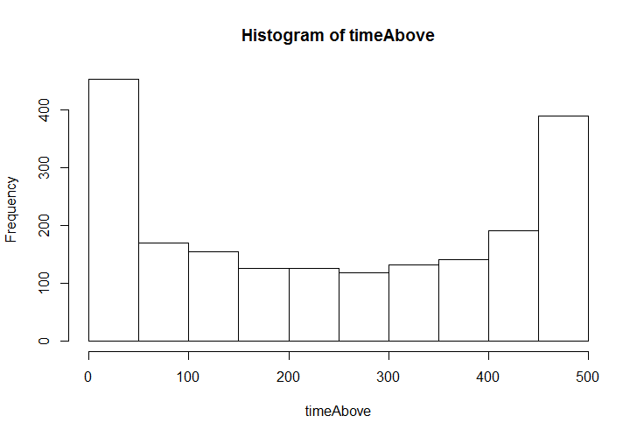

**Interpret the results. Was your intuition correct?**

**My intuition was very far from what we see above. I predicted that the trajectory of the random walk to spend on one side from 0 to switch every 100 time units. Over the course of over 500 time unites, the trajectory didn’t cross 0 once.**